

FACULTY OF ENGINEERING AND TECHNOLOGY BACHELOR OF TECHNOLOGY

Programming in Python with Full Stack Development

(303105258)

SEMESTER IV

Computer Science & Engineering Department



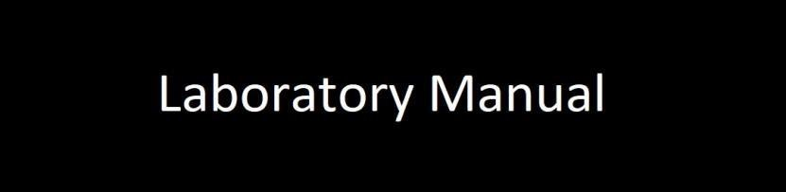

**CERTIFICATE**

*Mr./Miss* ***pandey sanjit vinod*** *with Enrollment No.* ***2303051057094*** *has successfully completed his/her laboratory experiments* ***Python with full stack with development******(***303105258***)*** *from the department of* ***Computer Science and Engineering*** *during the academic year* ***2023-2024.***



**Date of Submission ….…………… Staff In charge …..……………**

**Head of Department………….……**

DATE:-………………

**SET-1**

**Program-1:-**  A program that converts temperatures from Fahrenheit to Celsius and vice versa.

**CODE:-**

# C = (°F - 32) × 5/9;

# F = C * (9/5) + 32

while True:

t = input("Choose what you want to convert from: F or C: ").upper()

if t == "F":

f = float(input("Give me temprature in Fahrenheit: "))

c = (f - 32) * 5 / 9

c = round(c, 2)

print("Temprature in celcius: ", c)

break

elif t == "C":

c = float(input("Give me temprature in Celcius: "))

f = c * (9 / 5) + 32

f = round(f, 2)

print("Temprature in fahrenheit: ", f)

break

else:

print("Wrong input! try again!")

**output**

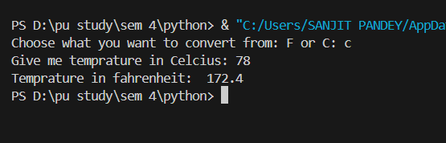

DATE:-………………

**SET-1**

**Program-2:-**  A program that calculates the area and perimeter of a rectangle.

**CODE:-**

l = float(input("Length of the Rectangle: "))

b = float(input("Breadth of the Rectangle: "))

p = 2 * (l + b)

print("Perimeter: ", p)

a = l * b

print("Area: ", a)

**OUTPUT**

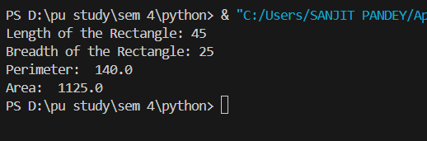

DATE:-………………

**SET-1**

**Program-3:-**  A program that generates a random password of a specified length.

**CODE:-**

import string

from random import choice

S = string.ascii_letters + string.digits + string.punctuation

l = int(input("Length of the password: "))

password = ""

for _ in range(l):

c = choice(S)

password += c

print("Your password is: ", password)

**OUTPUT:-**

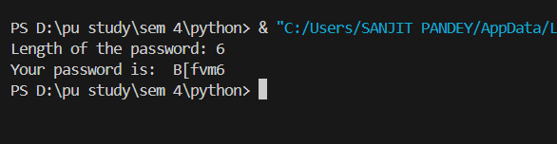

DATE:-………………

**SET-1**

**Program-4:-**  A program that calculates the average of a list of numbers.

**CODE:-**

l = [1, 2, 3, 4, 5, 6, 7, 8, 9]

count = len(l)

s = sum(l)

avg = s / count

print("Average: ", avg)

**OUTPUT:-**

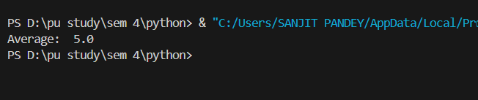

DATE:-………………

**SET-1**

**Program-5:-**  A program that checks if a given year is a leap year.

**CODE:-**

year = int(input("Year: "))

r = year % 4

if r == 0:

print("It's a leap year!")

else:

print("It's not a leap year!")

**OUTPUT:-**

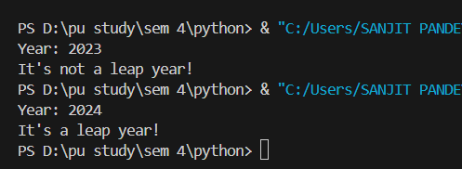

DATE:-………………

**SET-1**

**Program-6:-**  A program that calculates the factorial of a number.

**CODE:-**

n = int(input("Give me the number: "))

p = 1

for i in range(1, n + 1):

p *= i

print(p)

**OUTPUT**

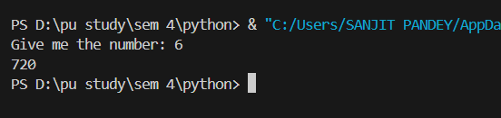

DATE:-………………

**SET-1**

**Program-7:-**  A program that checks if a given string is a palindrome.

**CODE:-**

s=input("Enter a string:").lower()

#reverse

r = s[::-1]

if s == r:

    print("It`s a palindrome")

else:

    print("It`s a not palindrome")

OUTPUT:

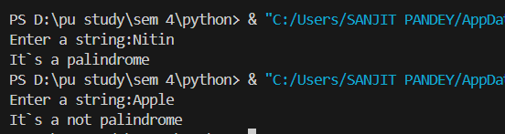

DATE:-………………

**SET-1**

**Program-8:-**  A program that sorts a list of numbers in ascending or descending order.

**CODE:-**

s = [1, 5, 3, 2, 4]

s.sort()

print("accending:-",s)

s.sort(reverse=True)

print("Decending :-",s)

**OUTPUT:**

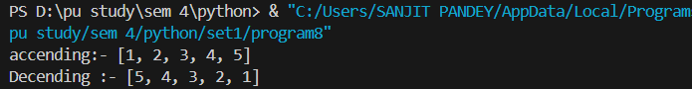

DATE:-………………

**SET-1**

**Program-9:-**  A program that generates a multiplication table for a given number.

**CODE:-**

s=int(input("Enter a number: "))

#s=3

for i in range(1, 11):

   print(f"{s} x {i} = {s*i}")

**OUTPUT:**

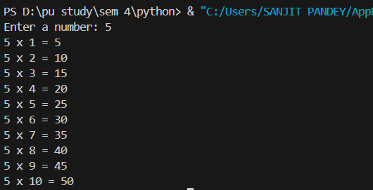

DATE:-………………

**SET-1**

**Program-10:-**  A program that converts a given number from one base to another.

**CODE:-**